**Backend Developer Hiring Assignment submission**

**HOME PAGE –**

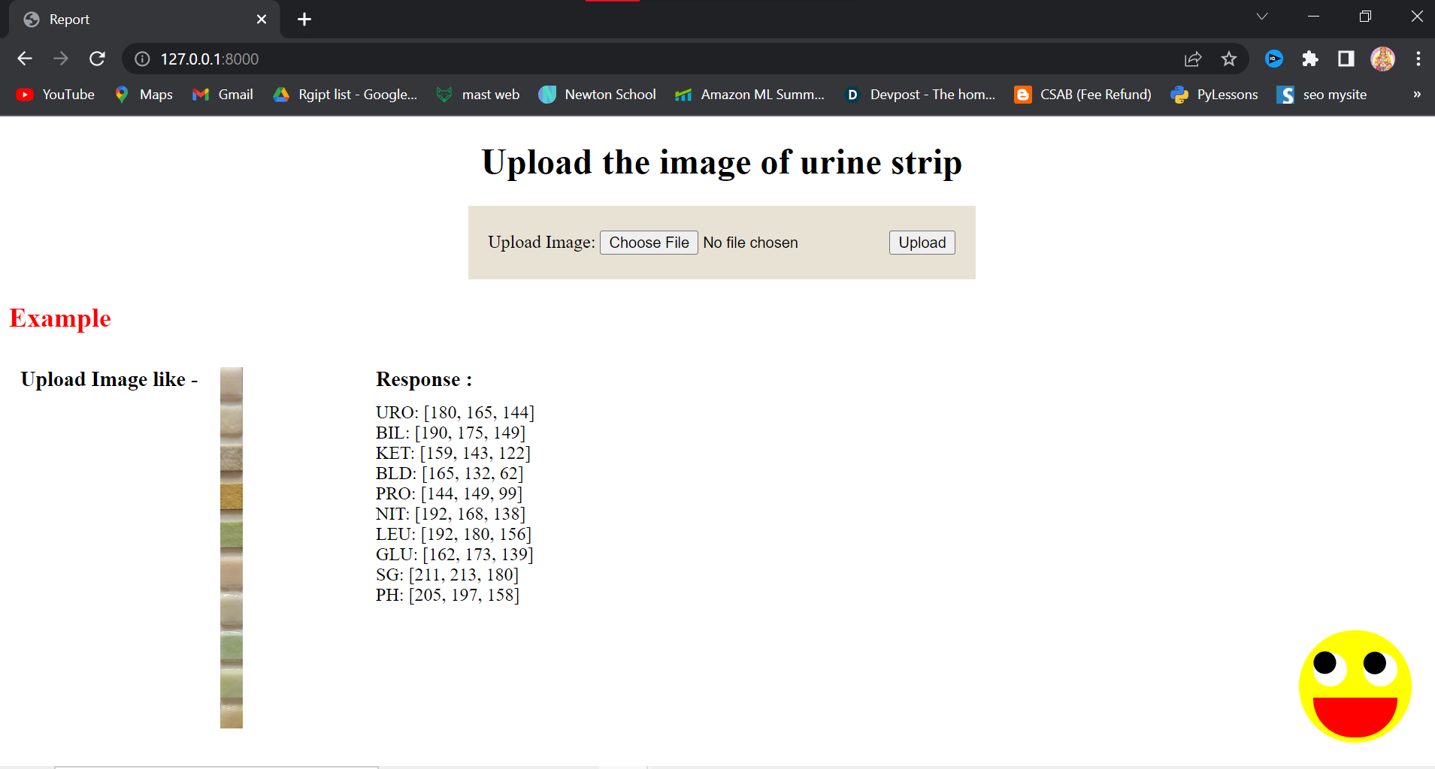

**OUTPUT –**

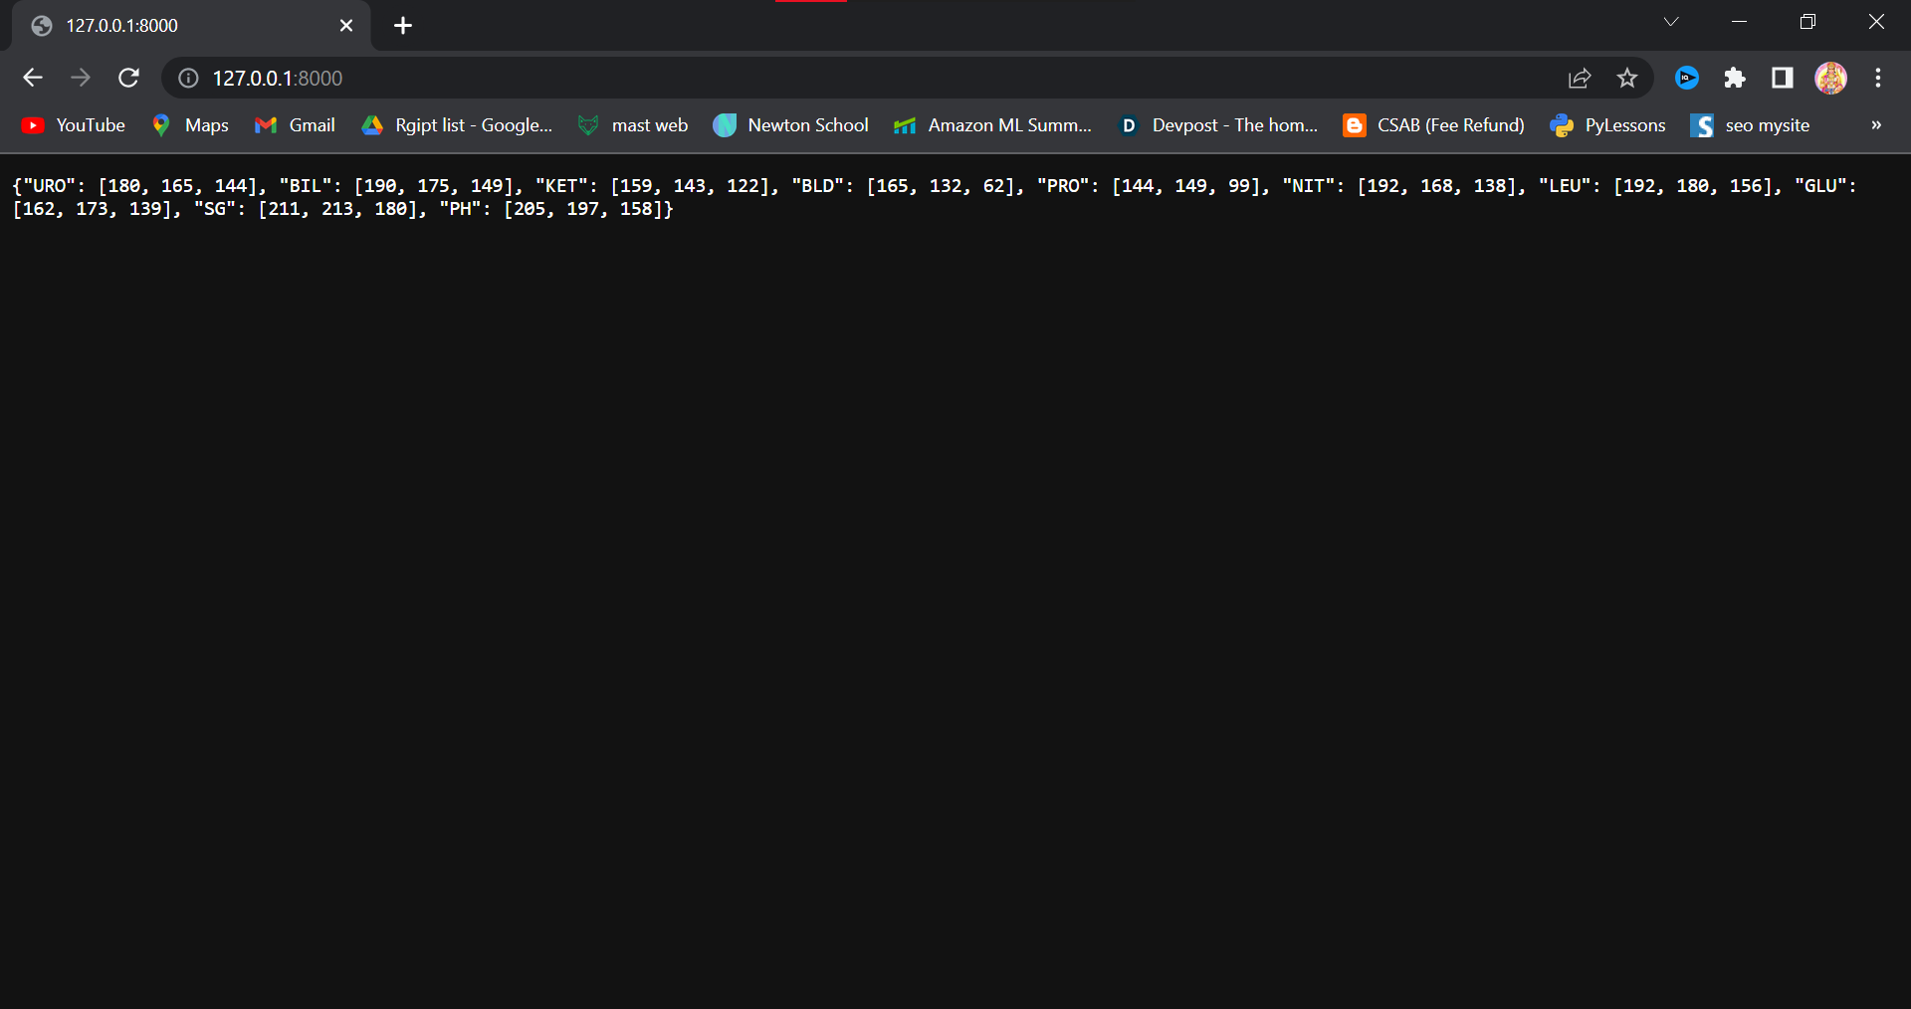

To run the project follow these steps :

1. Create virtual env
2. To install the dependencies in a virtual environment run in the terminal –

pip install -r requirements.txt

1. Finally Run the code in terminal –

python manage.py runserver

then go to -

http://127.0.0.1:8000/

1. You can also visit admin page , go

<http://127.0.0.1:8000/admin/>

admin user name – admin

admin password - admin